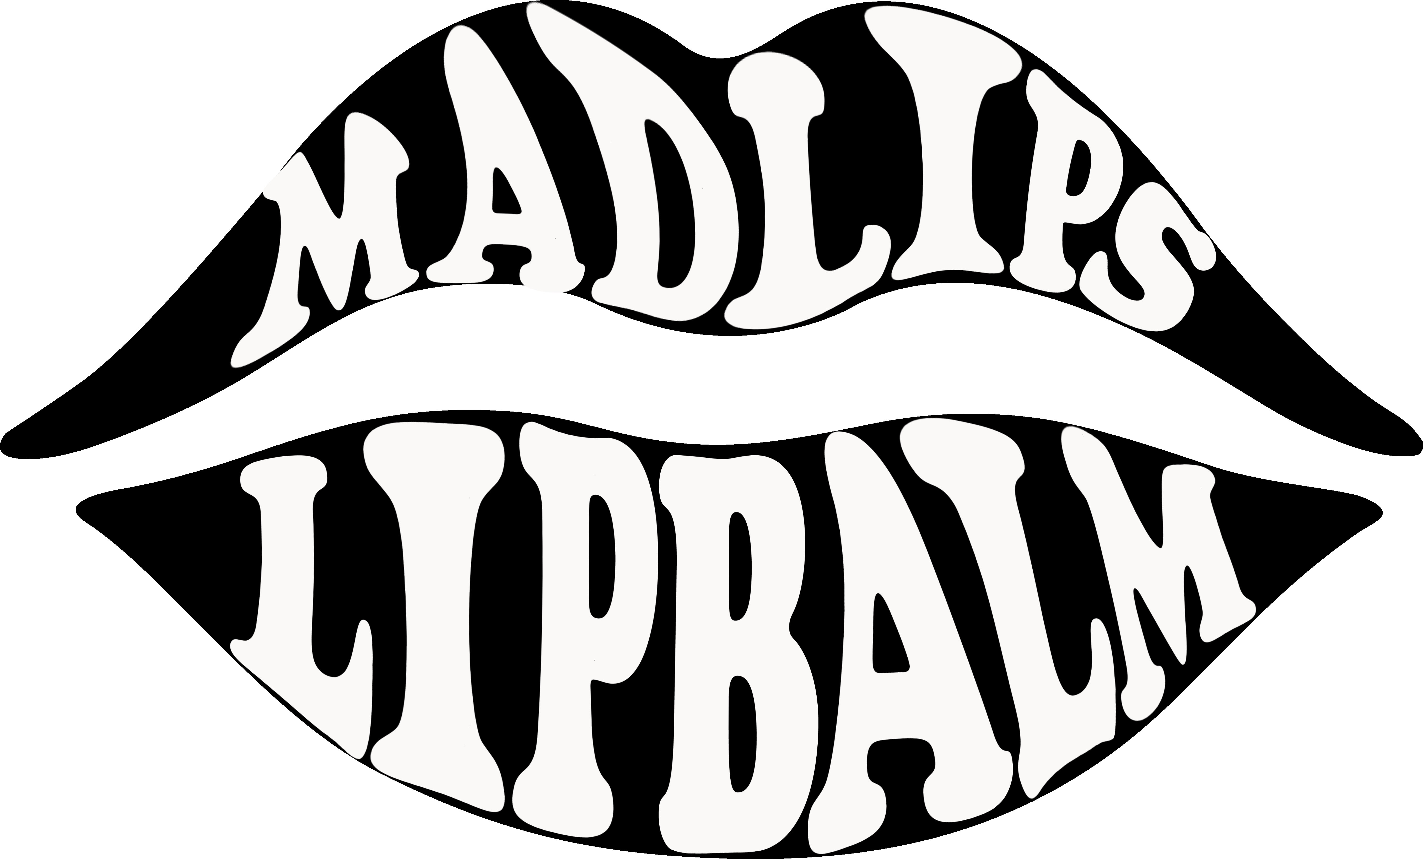
2323 N Moorpark Rd. Thousand Oaks CA 91360
(805)-338-1741

BUSINESS PLAN

Table of Contents

Executive summary —————-———————————————- 3
1.1 Industry Analysis ————————————————————- 3
2.1 Mission Statement ————————————————————- 4
2.2 Company Summary & Niche ——————————————————— 4
3.1 Management Functions ————————————————————- 5
Team Members ————————————————————- 5
4.1 Competition ————————————————————- 6
4.2 Products ————————————————————- 6
5.1 Start-up Summary ————————————————————- 7
6.1 Break-even Analysis & Financial Plan ——————————————— 8
7.1 Cash Budget ————————————————————- 9
7.2 Marketing Strategy & SWOT Analysis ———————————————- 9
Appendix
Balance Sheet ————————————————————- 11
Loan ————————————————————- 12
Bank Statement ————————————————————- 13

Executive Summary
MadLips is a start-up business specializing in all natural assorted flavored lip balm.
These handmade and organic products include flavors like Bee My Honey, Cabana
Coconut, Pure Mint, Lemonade, Think Pink, and a seasonal Pumpkin Spice. In 2013 the
Lip Balm industry exceeded $90.6 million in sales. We plan on maintaining an online
store as well as putting our products in local supermarkets such as Vons, Ralphs, and Whole Foods, also stores such as Barnes and Noble, Urban Outfitters, and
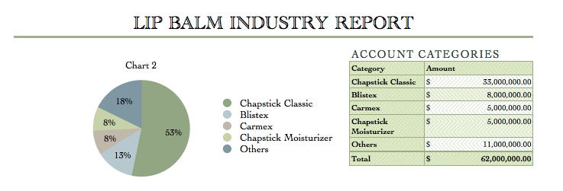
Anthropology. Because of our all natural ingredients our products contain no parabens and no sulfates. Our all-natural products are made from soy wax, coconut oil, shea butter, sweet almond oil, and essential oils. Lip balm is an en entire industry based on losing the product and buying more, it is a moisturizing creamy wax that customers apply to chapped or dry lips. Each of our products cost $1.99. MadLips is a business that loves to help the community and the people within it. Therefore our company would love to donate one dollar of every berry flavored lip balm Think Pink to breast cancer awareness and research. As well as to benefit the thirteen family members of our own employees who have been affected by this terrible disease.

1.1 Industry Analysis
Lip balm was one of the biggest hits of the 1880‘s. With vibrant colors and revolutionary flavors, there was no doubt that this new technology would have blasted into the future. This waxy gel is easily portable and moisturizes the driest of lips. Making fun in the sun more enjoyable, lip balm has shaped its way through the years.
Lip balm is an en entire industry based on losing the product and buying more, it is a moisturizing creamy wax that customers apply to chapped or dry lips.
Major companies such as Chapstick Classic, Blistex, Carmex, Chapstick Moisturizer Burt’s Bees, and others in 2013 combined brought in roughly $62 million.

2.1 Mission Statement
The mission of MadLips Lip Balm is to create organic and vegan products that heal, sooth and moisturize our customers lips. We plan on maintaining an online
store as well as putting our products in local supermarkets such as Vons, Ralphs, and Whole Foods, also stores such as Barnes and Noble, Urban Outfitters, and
Anthropology.

2.2 Company Summary & Niche
MadLips Lipbalm is a unique, one of a kind, all natural lip balm company. In order for a company of any type to thrive you must be equipped with a team that is passionate and truly loves what they do. Here at MadLips that is defiantly the case with our team members. We are all for natural and non-processed ingredients which truly separates us from the rest of lip balm companies. With our sleek designed lip balm container it makes it super convenient to take with you on the go. Not to mention our price beats other competitors. When it actually comes down to purchasing lip balm we believe our MadLips LipBalm is the perfect choice because of our nourishing ingredients that makes your lips so smooth it’ll drive you mad.
MadLips Lip Balm is a provider of all natural, organic, and vegan lip balm including flavors like:
-Bee My Honey
-Cabana Coconut
-Pure Mint
-Lemonade
-Think Pink
We will also feature a fall/winter seasonal flavor called Pumpkin Spice.

3.1 Management Functions
The goal of MadLips is to bring customers moisturized lips in an all natural, organic, and vegan way.

Team Members:
CEO- Kailey Jones: Manages company and oversees major decisions regarding the company.
COO- Mikayla Ybarra: Assists CEO in organization and overseeing company policies and decisions regarding the company.
CFO- Reina Tuffley: responsible for the company's present financial condition, so they must decide how to invest the company's money, taking into consideration risk and
liquidity. Not only is a CFO responsible for a company's past and present financial situation, they is also an integral part of a company's financial future.
Banker- Abby Portnoy: TBD
Marketing Manager- Dani Schneider: Researching and reporting on external opportunities, understanding current and potential customers, managing the customer journey (customer relationship management), developing the marketing strategy and plan,and management of the marketing mix.
Marketing Assistant- Jessica Cortes: assist manager in marketing strategies, understanding customers and researching opportunities.
Sales Manager- KC Leak: Direct the actual distribution or movement of a product or service to the customer. Analyze sales statistics gathered by staff to determine sales potential and inventory requirements and monitor the preferences of customers.
Sales Assistant- Kelly Haver & Harrison Pope: Assist monitoring preference of customers, analyze data of customers interests and dislikes, and forming sales strategy and method.
Tech- Juan Ventura & Riley O'shaughnessy: create and maintain website, create effective commercial, create logo.
Human Resources- Marissa Acosta & Ruby Sibrian: Maintains management guidelines by preparing, updating, and recommending human resource policies and procedures. Prepares employees for weekly goals and assignments.
Public Relations- Andrea Esparza & Ryan Zamora: Manage reputation of the company. Plan and direct public relations programs designed to create and maintain a favorable public image for company.

Each member of the MadLips staff has multiple years of experience through the Thousand Oaks High School EThOS Entrepreneurship Academy. The EThOS Entrepreneurship Academy teaches students the fundamentals of running a business and how to work together to be successful.The business was formed in September of 2014 and will continue to stay in operation throughout the various trade shows the company and it’s staff plan on attending throughout the year.

4.1 Competition
Main competitors such as Chapstick Classic, Blistex, Carmex, Chapstick Moisturizer Burt’s Bees, and others in 2013 combined brought in roughly $62 million.
(The lip balm industry is regulated by the Food and Drug Administration, and ingredients for the product, which is usually classified as a cosmetic, must be approved by the agency)
4.2 Products
The product line of MadLips is as follows:
Bee My Honey
The sweet taste of honey on a warm summer’s day. The perfect mix of honey extract spread upon the finest of lips makes for the best lip balm design ever. Straight out of the bee hive, you will not be disappointed.
Pure Mint
The quivering, yet chilling taste of mint. With the sweet bliss of peppermint, you’d think it was Christmas. If you don’t know what pure mint tastes like, you haven’t lived.

Think Pink
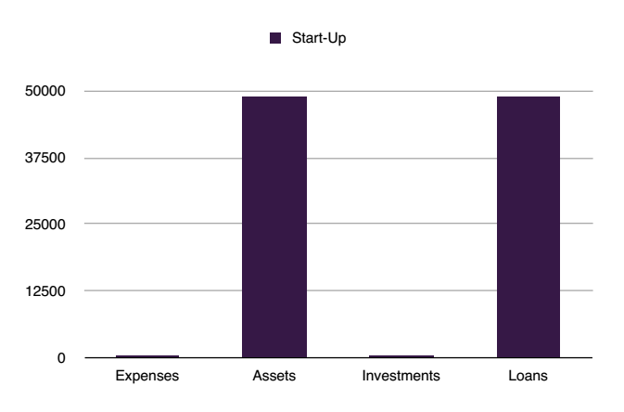
Supporting Breast Cancer. $1.00 goes to finding a cure for this deadly cancer. The smooth rich flavor of pink berries for the finest of lips. Stretching the boundaries of taste, our berry flavor is on top when it comes to precision.
Cabana Coconut
The self explanatory cabana coconut. Basically, you have a tropical island on your lips. You can either enjoy what you have, or go somewhere else.
Lemonade
When life gives you lemons, make lip balm. You get the sweet taste of lemon without the sting. Our tangy new flavor that will drive you mad.
Pumpkin Spice
This a one of a kind seasonal flavor. Containing the delightful taste of pumpkin, this flavor does not disappoint the Fall and Winter lovers.

5.1 Start-up Summary
The start-up expense for MadLips is focussed on beauty and cosmetics. The start-up costs for MadLips is $48,976.99. MadLips secured a loan of $48,976.99 from the VE Central Bank to cover our start-up costs.

6.1 Break-even Analysis & Financial Plan
Our total costs, which is detailed below, totals $67,651. To cover our costs we have to sell 33,995 units to break-even.
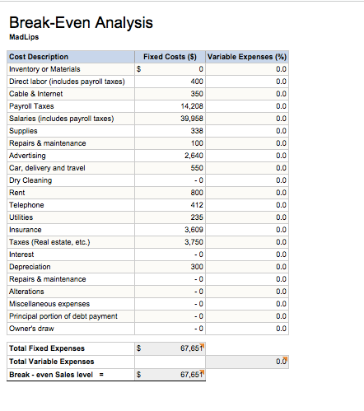
MadLips is stationed in an office with a warehouse, that has rent $800 a month. Our electricity, gas, and water costs us $235 monthly. All fifteen people has a cell phone that the company pays them for $412 a month. We pay $350 a month for our high speed internet in the office. We pay $120 a month for every employee to have life insurance. Likewise, we pay $500 a month for employees retirement funds. For each employee to have business insurance we pay $487.50 per month.To keep our employees safe we pay workman's compensation for $4,093.79 monthly.
Our employees are also covered with health insurance that costs us $3,608.70 per month. We own two cars to deliver our orders of lip balm with two people in each car. We have two Honda Civics, which cost $26,020 because it ensures safety for our employees while they are driving around town. Our car insurance costs us $550 a month and gas is approximately $450 a month. Our property management costs us $3750 monthly. MadLips employees enjoy a clean work space, so we have an extra expense which is janitorial services. It costs us $600 a month.
7.1 Cash Budget
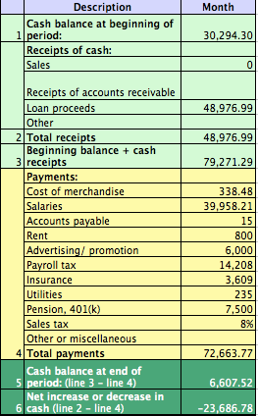
The beginning cash balance indicates that we have $30,294.70. We found that number by calculating the bi-weekly pay together from everyone's pay checks. The loan process number shows how much Ms. Phillips gave to us to help start out our company. The beginning cash and balance receipts are the loan and shipping put together. We pay everyone bi-weekly. The cost of merchandise is all the ingredients of the lip balms and the tins and the tax from buying it, added together. The salaries are everyone's net pay added together. Our accounts payable are all the 15 people in the company. Our rent is $800 per month. It's half a warehouse half an office building. Advertising is $6,000 to get our name out. Payroll tax is all total deductions added up. The insurance is everyone's health insurance. Utilities are all the office supplies added together. The pension is $7,500 because that represents what they are covered for, like their retirement fund. The sales tax is 8% because it shows how much it is for shipping.

7.2 Marketing Strategy
SWOT Analysis

Strengths
MadLips strengths include being an all natural lip balm company. This is is very appealing to a lot of consumers because it means they don’t have to put nasty chemicals on their lips. MadLips is also attractive to the consumers because of the sleek packaging that is made out of recycled materials. Another one of our strengths is our low cost of $1.99 per lip balm as compared to our competitors cost of $2.94 - $4.99.

Weaknesses
MadLips weakness is that we are a new company that is trying to get our name out there in the beauty world. Since we are a new company we do not know how to market efficiently to our target market. We are inexperienced in comparison to other lip balm companies causing us to be the underdogs.

Opportunities
MadLips has many opportunities as a first year company. Since our products are all natural, we have the chance to go to local farmers markets to sell our products, sell to health food stores, and sell locally. We also reach a different market than other lip balm companies since we are all natural and vegan.
Threats
Our threats would be the lip balm companies that have been around for years and have taken the industry by storm. Our competitors include; Abreva, Burts Bees, Baby Lips, Blistex, Chapstick, Carmex, and Eos. We are a new company so we have to work a lot harder to get MadLip’s name out in the beauty industry.

Appendix
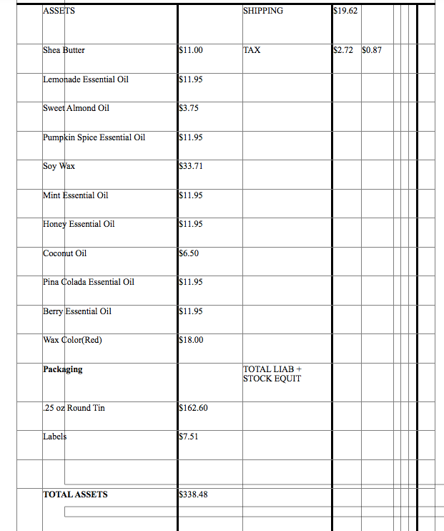
Balance Sheet

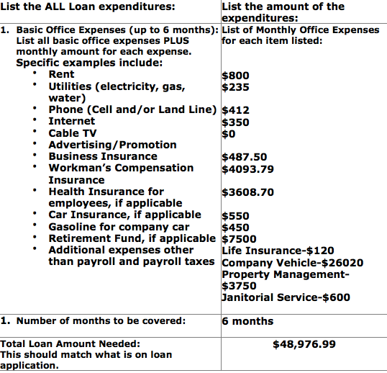
MadLips Loan Expenditures

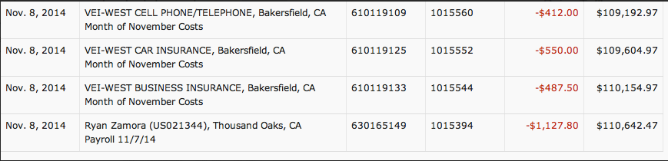
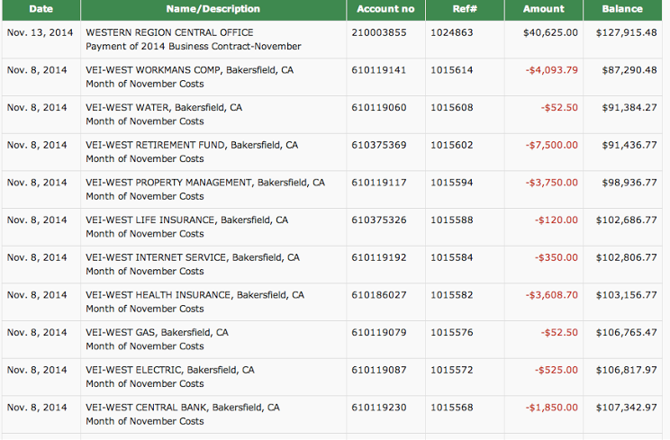
MadLips Bank Statement

